OPM - Reporting - Frontend Module Assembly Deployment Guide

Revision History
Author | Revision Number | Date
TCSASSEMBLER | 1 | 2/22/2014

Deployment Instructions 4
1. Organization of Submission 4
2. Application Setup 4
3. Ant .Properties File 5
4. Build Scripts Setup 5
5. Database Setup 6
6. Deployment Instructions 7
7. Starting 7
8. Verification 7
8.1. Unit Tests 7
8.2. Web Tests 8
8.3. Login 9
8.4. Reports Page 9
8.5. Make Home Page 12
8.6. Reportings 13
8.6.1. Account Balance History 13
8.6.2. Account Notes By User 13
8.6.3. Account Type Totals 13
8.6.4. Active Credit Balances Over Twenty File Dollas 14
8.6.5. Balanced Scorecard Accounts 14
8.6.6. Balanced Scorecard Lockbox 15
8.6.7. Balanced Scorecard Payments 16
8.6.8. Calculation Audit Trail 16
8.7. Reportings In other pages. 29
9. Resource Contact List 32

Deployment Instructions

Organization of Submission

Folder | Description
conf | Contains application configuration files
lib | Contains dependencies
src | Contains all source files
docs | Contains documentation (this file)
test_files | Contains the test files
log | Contains the test log files
conf/jpa | Contains the JPA mapping and persistence configuration
conf/ejb | Contains the EJB configuration
conf/rules | Contains the business rule definitions
conf/web | Contains the web application configuration files (including spring MVC bean definitions)
conf/ear | Contains application wide configuration (including the datasource definition)
conf/jboss | Contains application changes to the JBoss configuration
src/web | Contains the web application sources
src/java/core | Contains java sources shared across modules
src/java/ejb | Contains java sources for the EJB module
src/java/web | Contains java sources for the front end web application
src/java/tests | Contains java test sources
build-dependencies.xml | Declaration of build dependencies
build.properties | Externalized build configuration
build.xml | Ant build script

Application Setup

The application is tested with the following stack

- Java 6 (http://www.oracle.com/technetwork/java/javase/downloads/index.html)
- JBoss EAP 6.1 (http://www.jboss.org/jbossas/downloads/)
- Ant 1.8.1 (http://ant.apache.org/)
- PostgreSQL 9.2.4 (http://www.postgresql.org/)

The following 3rd party libraries are packaged with the submission
- Drools 5.5
- Spring MVC 3.2.3
- Hibernate 4.2.3
- Joda-Time 2.3
- JUnit 4.10

Ant .Properties File

Property Name | File property is stored | Example Setting
jboss.home | build.properties | D:/Servers/jboss-eap-6.1
loggerName | build.properties | gov.opm.scrd
supervisorRoleName | build.properties | supervisor
defaultPreferenceId | build.properties | 1
log_dir | build.properties | D:/opm_log
postedPendingApprovalStatus.id | build.properties | 1
postedPendingApprovalStatus. name | build.properties | Payment Status 1
redepositPeriodType.id | build.properties | 1
redepositPeriodType. name | build.properties | DEPOSIT
dedepositPeriodType.id | build.properties | 2
dedepositPeriodType. name | build.properties | DEDEPOSIT
csrsRetirementType.id | build.properties | 1
csrsRetirementType. name | build.properties | Retirement Type 1
successCalculationStatus.id | build.properties | 1
successCalculationStatus. name | build.properties | Calculation Status 1
db.driver | build.properties | org.postgresql.Driver
db.url | build.properties | jdbc:postgresql://localhost:5432/scrd
db.user | build.properties | postgres
db.pass | build.properties | 123456

Build Scripts Setup

build.xml – compiles, packages and deploys the application
Main targets:

clean removes all generated files
compile-core compiles shared java sources
compile_tests compiles java test sources
test run the test cases
compile-ejb compiles EJB java sources
compile-war compiles web application java sources
configure-ear performs replacement of values for EAR configuration files
configure-ejb performs replacement of values for EJB configuration files
configure-war performs replacement of values for web app configuration files
db-clear clears the contents of the tables
db-create creates the tables and sequences
db-drop drops the tables and sequences
db-test-data recreates the test data
deploy deploys the EAR artifact
deploy-jdbc-driver copies the jdbc driver module into jboss
dist-core creates the core distribution
dist-ear creates the EAR artifact
dist-ejb creates the EJB distribution
dist-war builds the war file

Default target: deploy

Database Setup

Note: for some steps, you can use the ant script to execute them, but make sure you configure the build.properties first.

- Setup PostgreSQL 9.2.4
- Create the database “scrd” using your client. (you may change the DB name, but update your JDBC URL accordingly)

- Execute script src/sql/create-schema.sql and src/sql/triggers.sql to create the required objects (“ant db-create” will perform the same step)
- Execute script ant db-test-data” to insert test data

Setup Database Driver module on JBoss

- Copy conf/jboss/modules into the modules folder of your EAP installation -${jboss.home}/modules/system/layers/base (“ant deploy-jdbc-driver” will perform the same step)
- Add the following entry to ${jboss.home}/standalone/configuration/standalone.xml just after the h2 driver declaration on the datasources/drivers subsystem

<driver name="postgresql-jdbc4" module="org.postgresql">
<driver-class>org.postgresql.Driver</driver-class>
</driver>

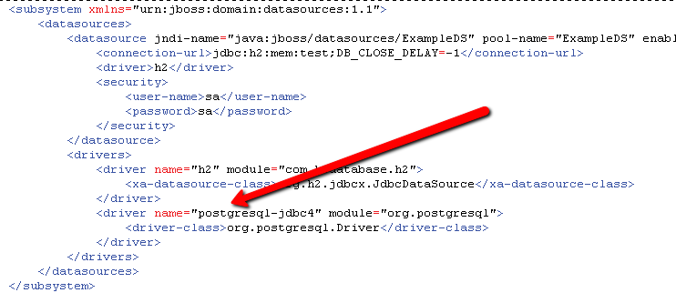

Note: This step can also be done via the jboss command line interface with the following command:

/subsystem=datasources/jdbc-driver=postgresql-jdbc4:add(driver-name=postgresql-jdbc4, driver-class-name=org.postgresql.Driver, driver-module-name=org.postgresql)

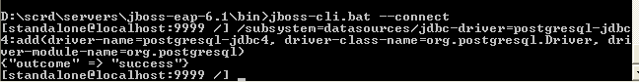

Cleanup scripts: (execute only when done with testing)
• When needed, execute src/sql/clear-data.sql to clear the database tables(“ant db-clear” will perform the same step)
• When needed, execute script src/sql/drop-schema.sql to delete all application objects (“ant db-drop” will perform the same step)

Deployment Instructions

- Modify build.properties to reflect the deployment environment settings. (log_dir must be an existing directory)
- Setup the database as described in the previous section
- Execute “ant deploy”

Starting

Start JBoss. The application is automatically started when the JBoss server is started.

Please note that you may receive a warning (JBAS011054) regarding EAP 6.1 and Spring 3.2.3, you may safely ignore this warning per

https://community.jboss.org/thread/231638?start=0&tstart=0

Verification

Unit Tests

All the reporting unit tests are integrated into this project, check:
addReportTests#addReportTests:
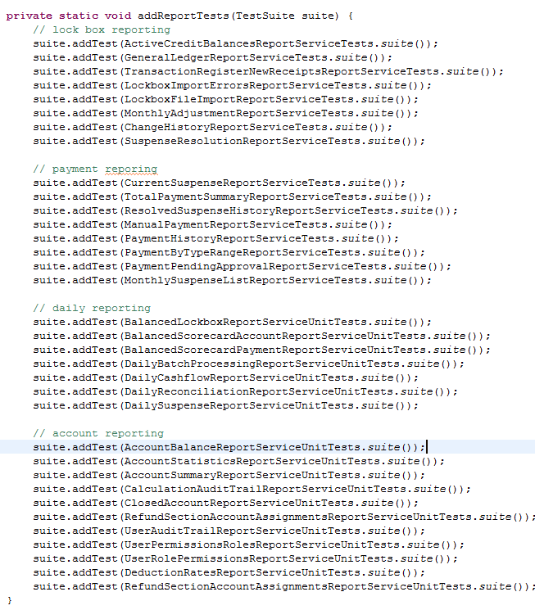

Run “ant test”, you should see all unit tests can pass.

Web Tests
When started, open the default URL in your browser http://localhost:8080/scrd/, this should show you the test page for CRUD and to execute the calculation.

Note: you may want to turn on DEBUG logging on the server, just add following line to the server configuration (jboss-eap-6.1/standalone/configuration/standalone.xml) under the logging subsystem – make the changes the before starting the server:

<logger category="gov.opm.scrd">
<level name="DEBUG"/>
</logger>

Make sure you change the threshold of the appender to DEBUG too.

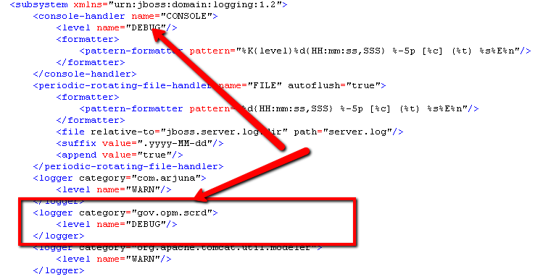

Login
Enter user:user1 and password:123456 to login
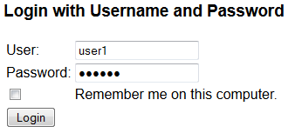

You will be direct to the view account page

Reports Page

Clicks the “Reports” tab:

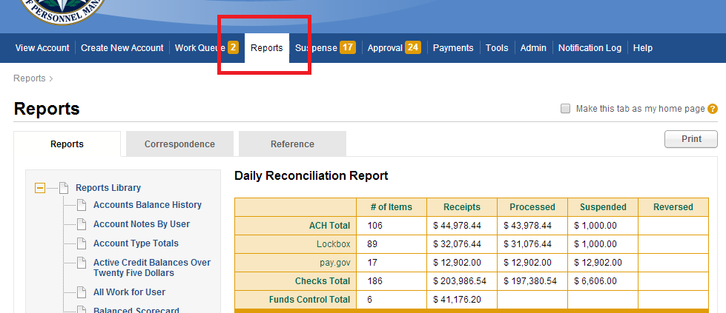

You can switch the tabs
Reports tab:
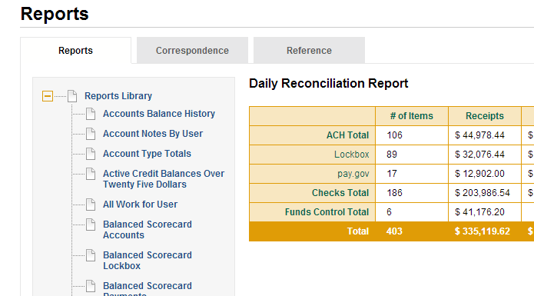

The Correspondence tab:
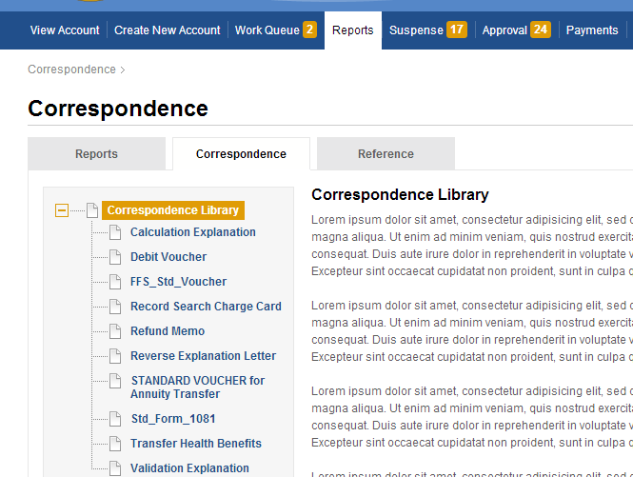

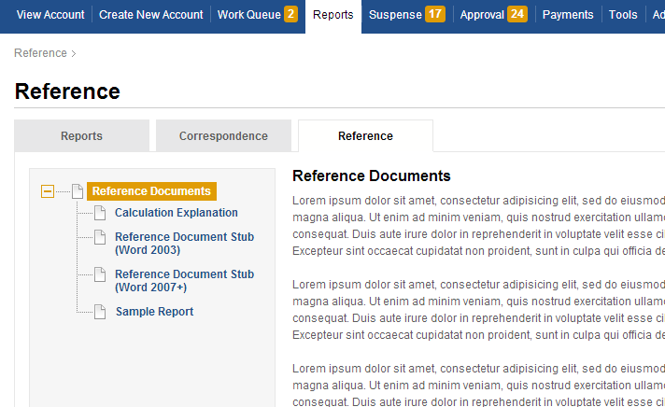

Note, that the page title and the breadcrumb will change.

Make Home Page

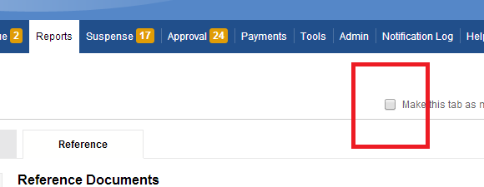

Clicks the “Makes this tab as my home page” button, then
Go to http://localhost:8080/scrd/
Then it will automatically redirect to http://localhost:8080/scrd/report/view
To retrieve report and display it are final fix issues.

Reportings

Account Balance History

Use the csd (other csd may not have data): 919259
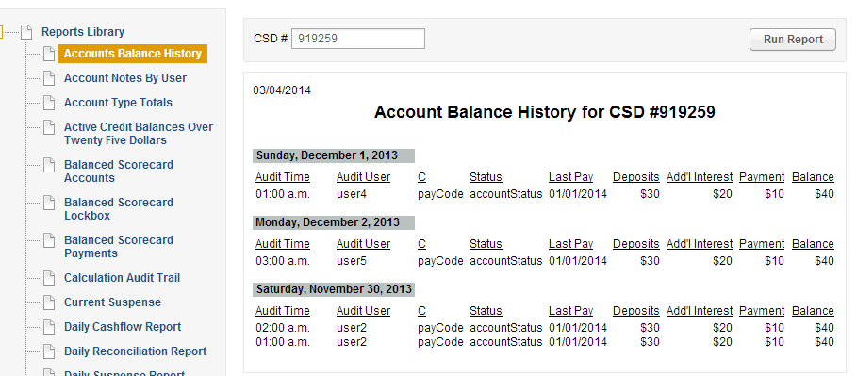

Account Notes By User

Use the csd (other csd may not have data): 919259
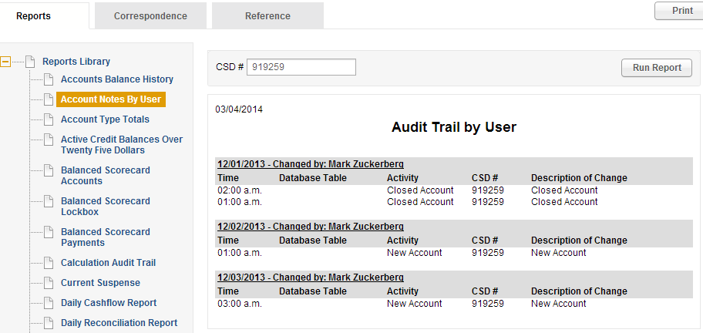

Account Type Totals

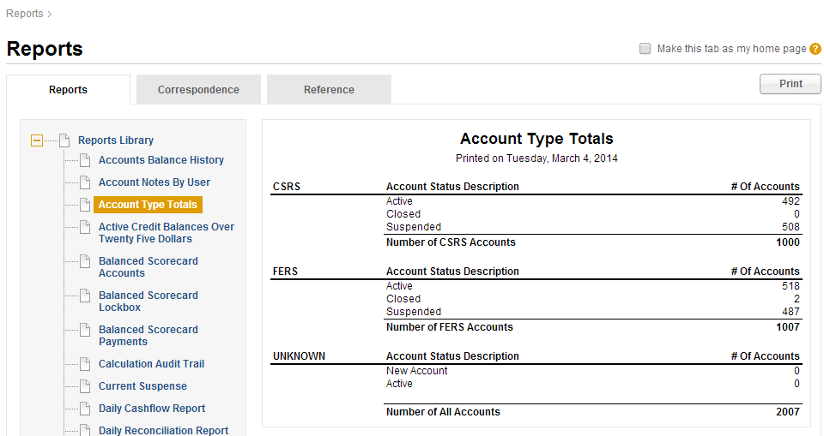

Active Credit Balances Over Twenty File Dollas

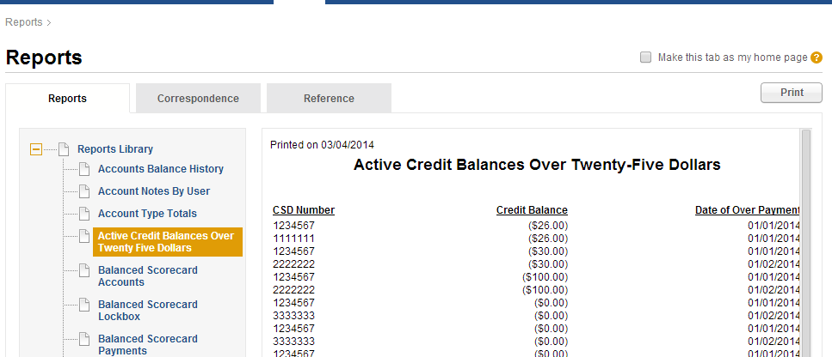

Balanced Scorecard Accounts

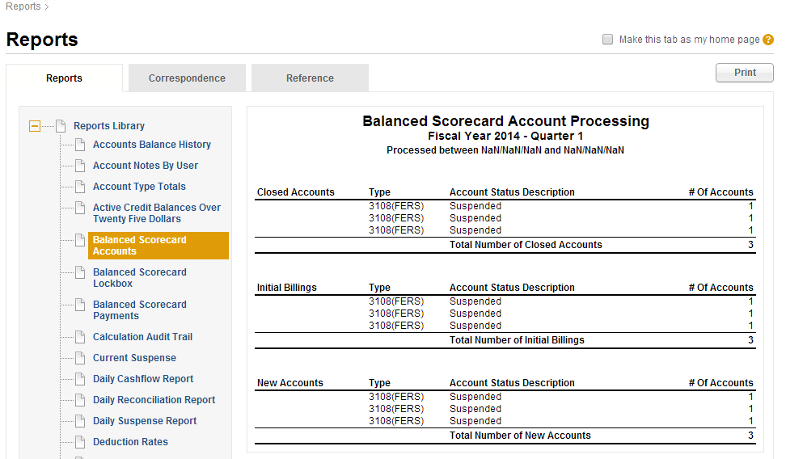

Balanced Scorecard Lockbox

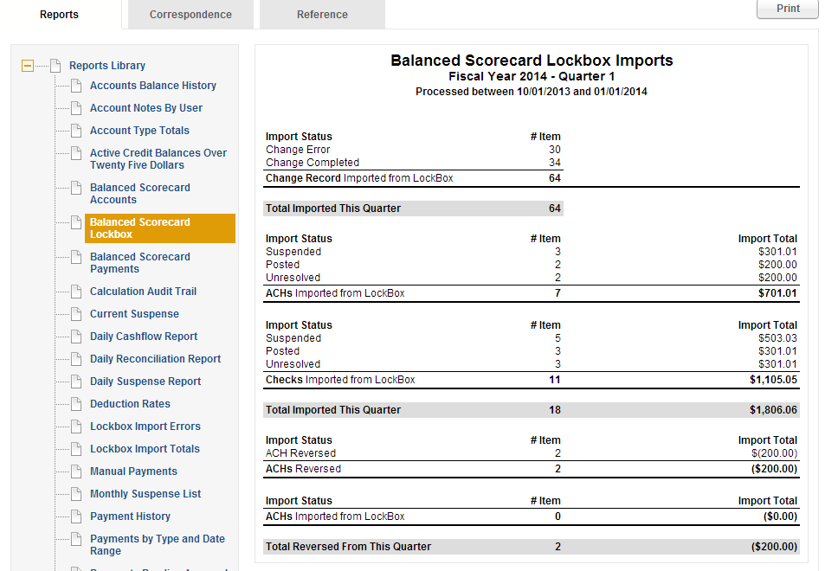

Balanced Scorecard Payments

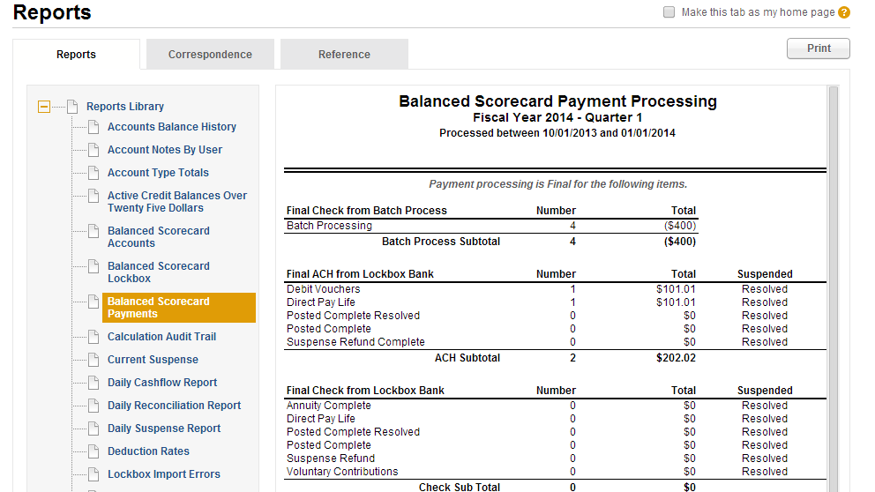

Calculation Audit Trail

Use the csd: "909219", other csd may not have data.

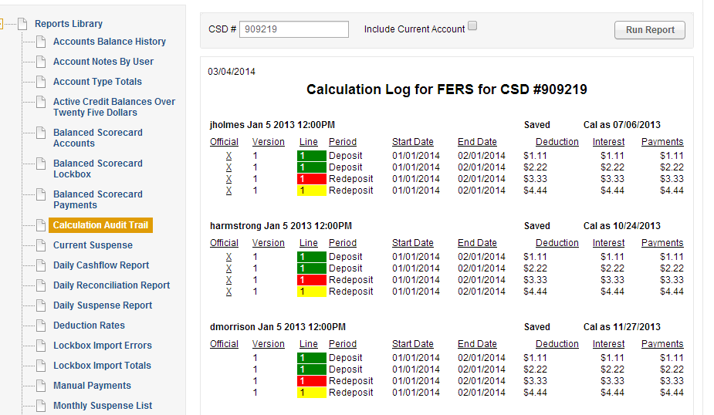

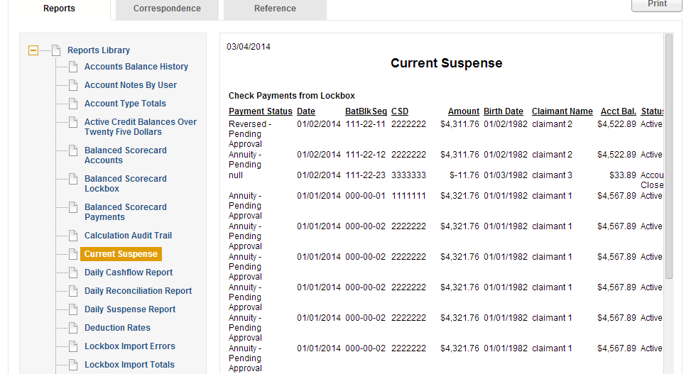

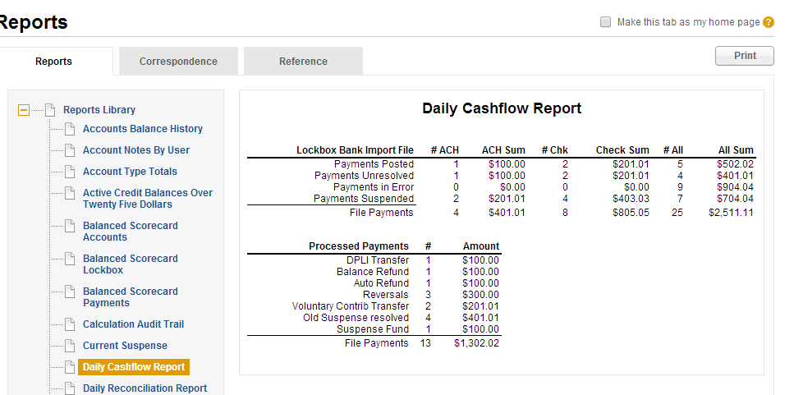

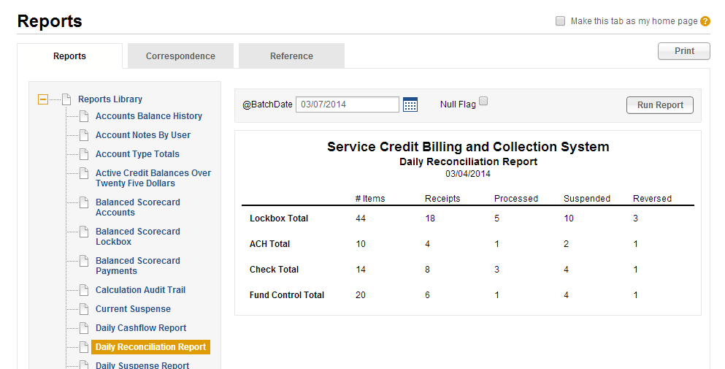

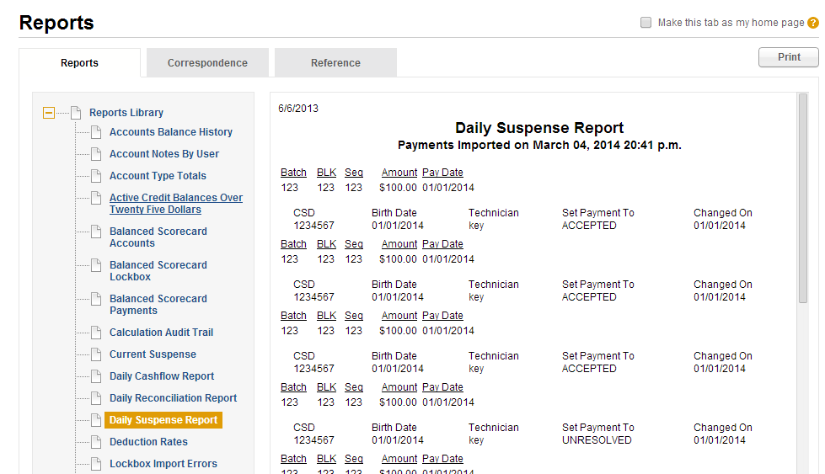

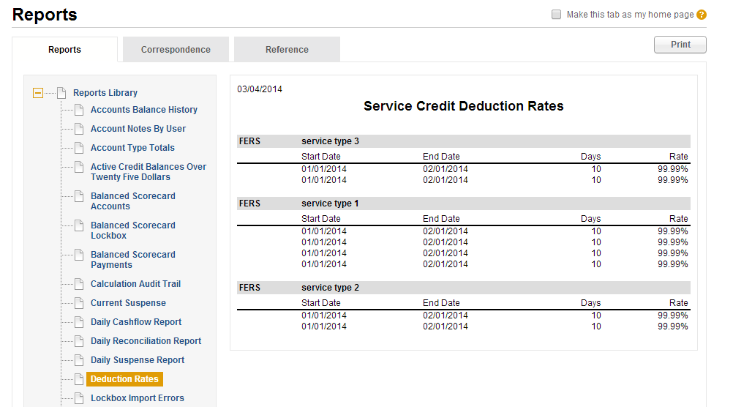

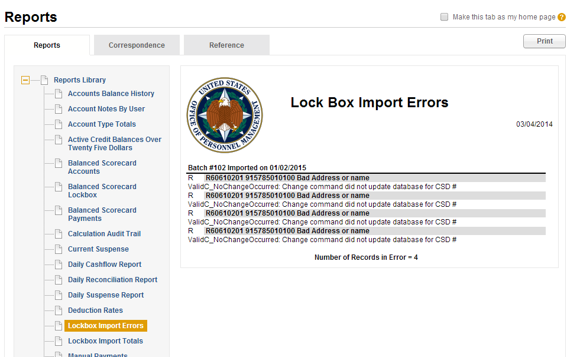

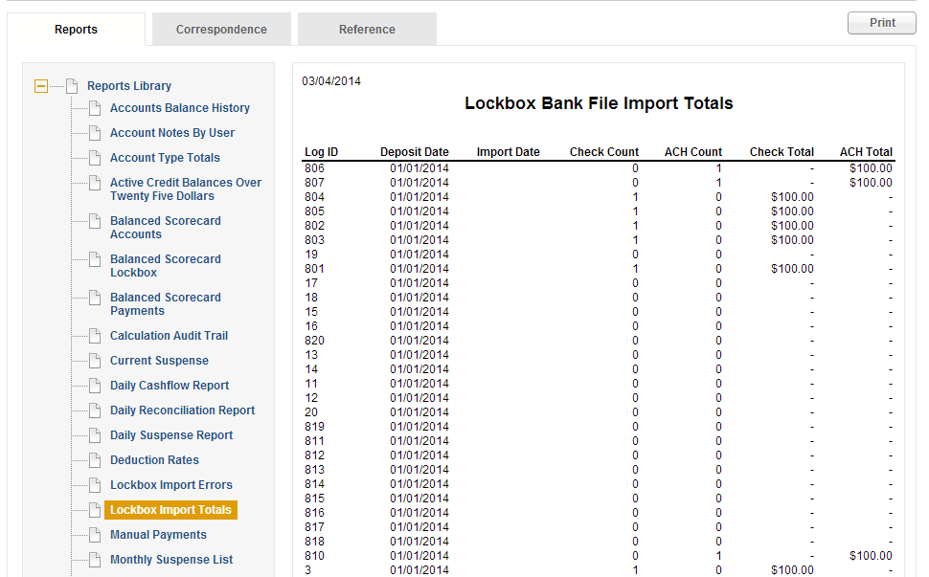

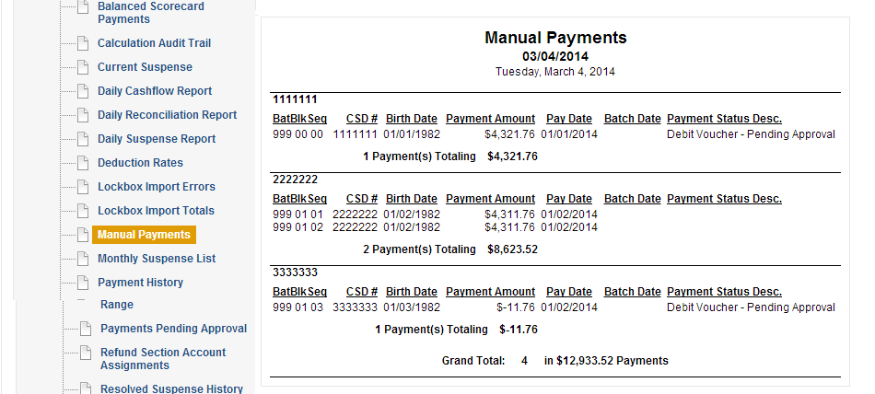

Please select “January 2014” for this case:
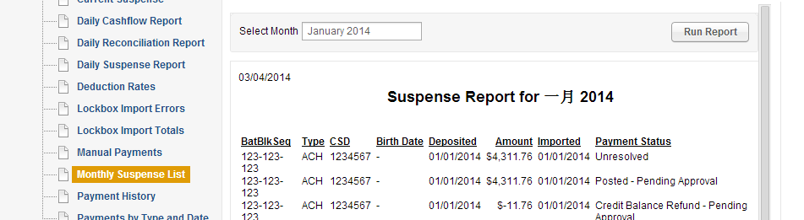

Plse use csd 919259 for this case:
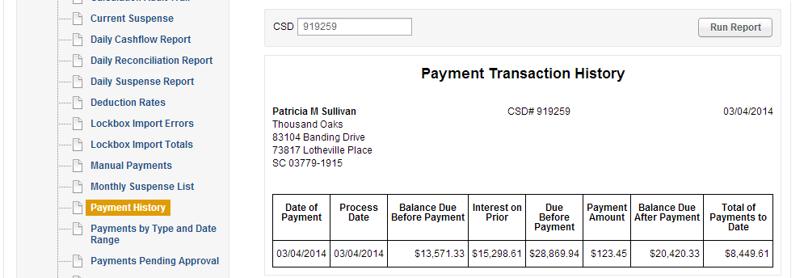

Select from 01/01/2014 – 03/19/2014
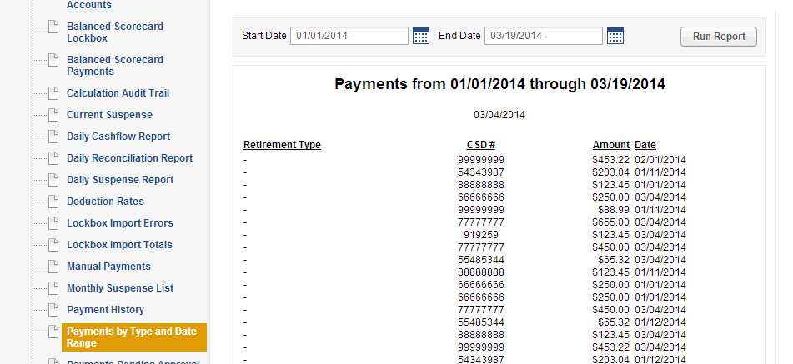

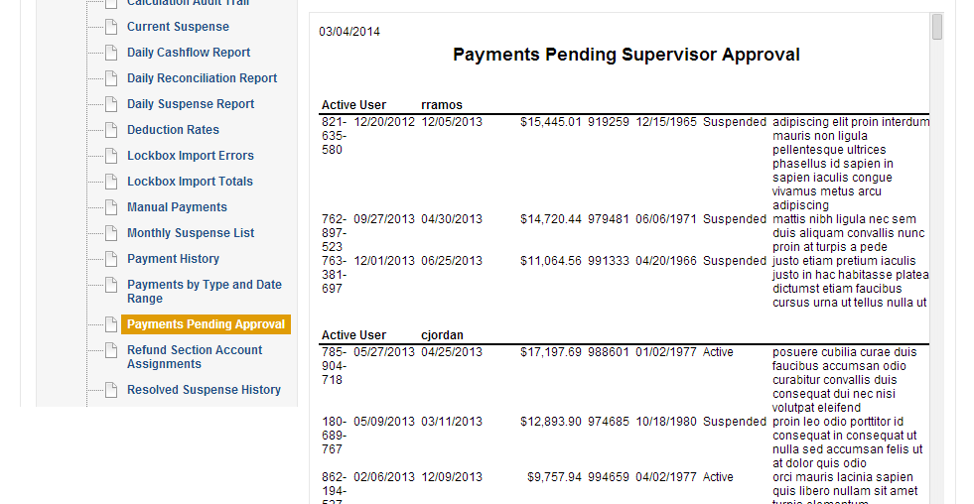

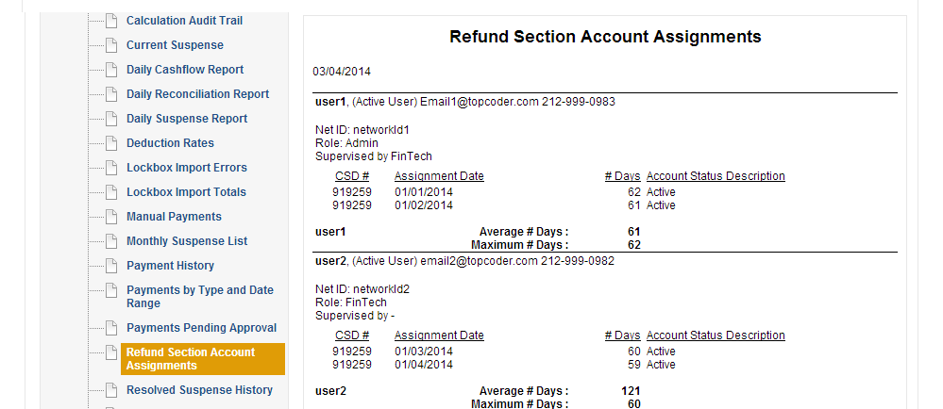

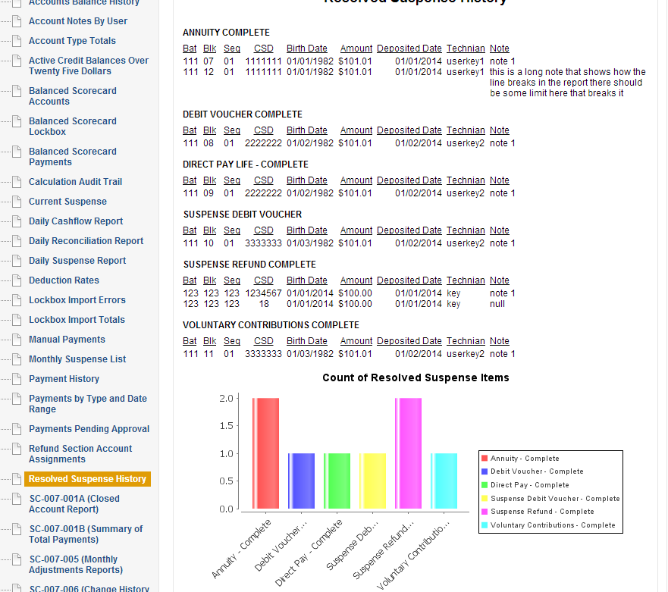

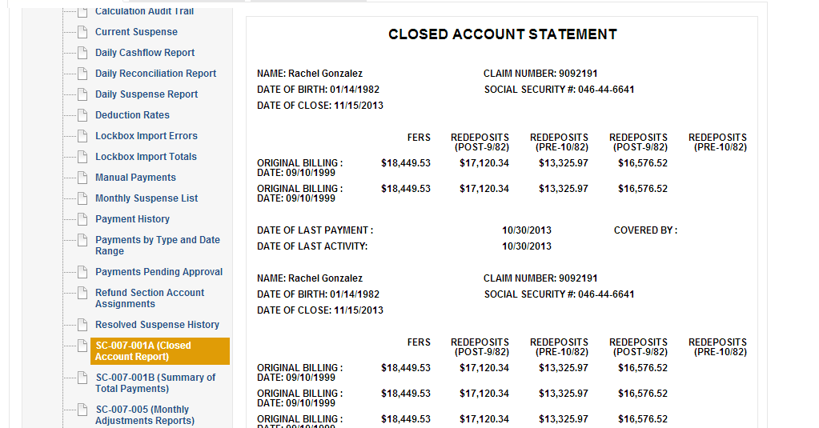

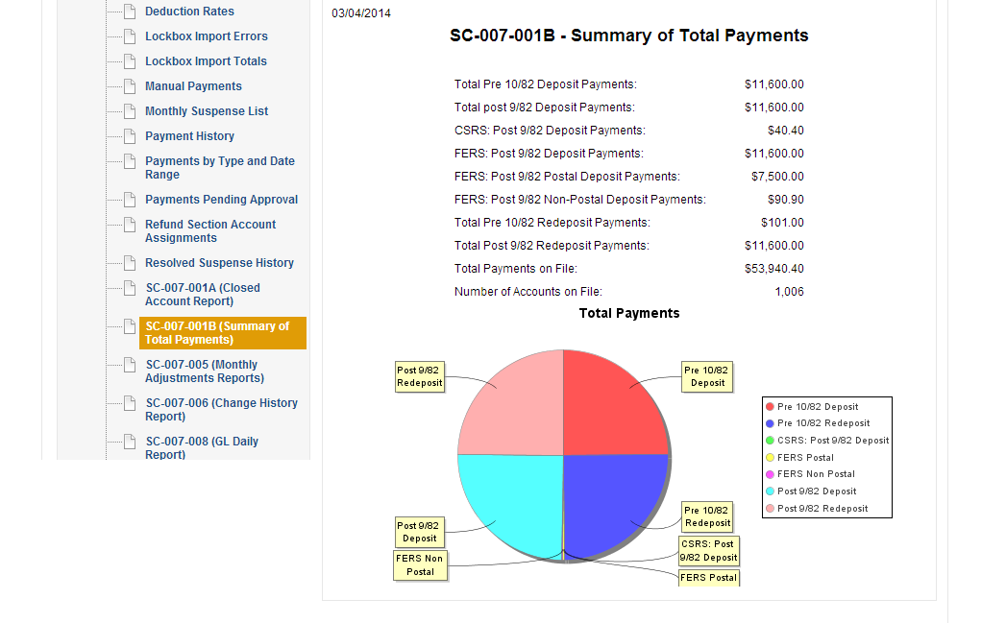

Choose the date from 01/01/2014-03/04/2014 for this case:
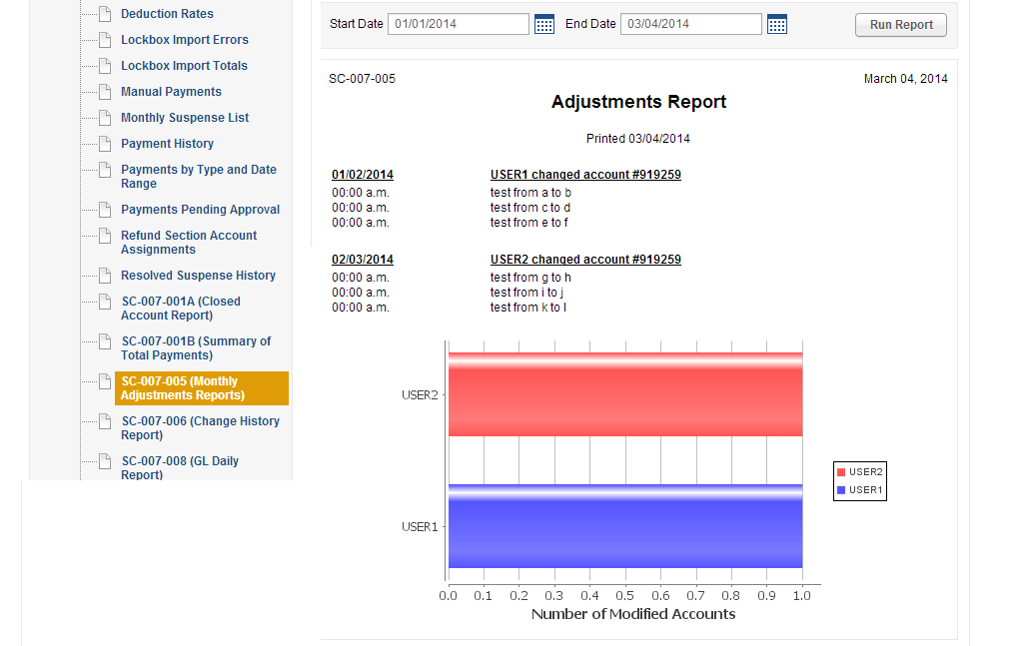

Use csd: 919259 for this case:
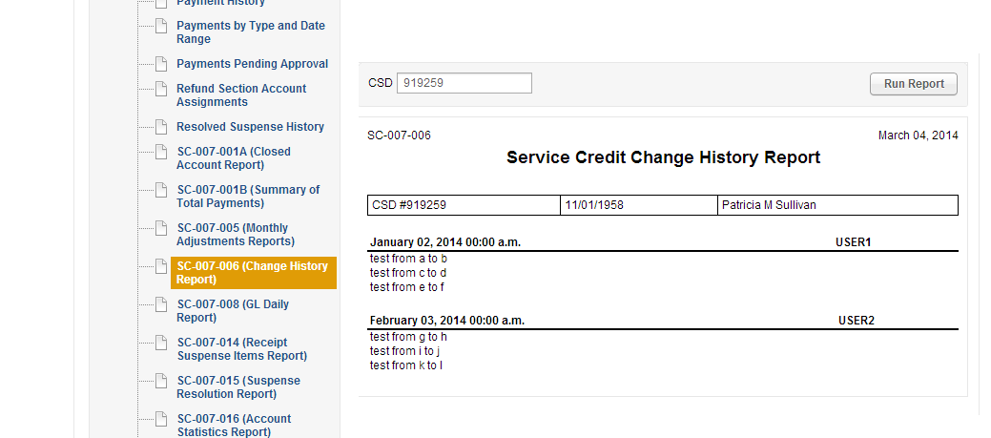

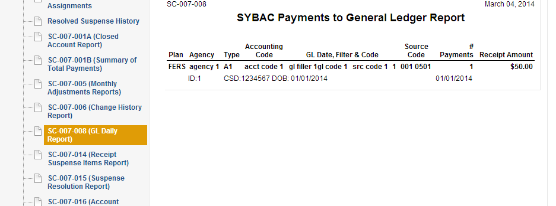

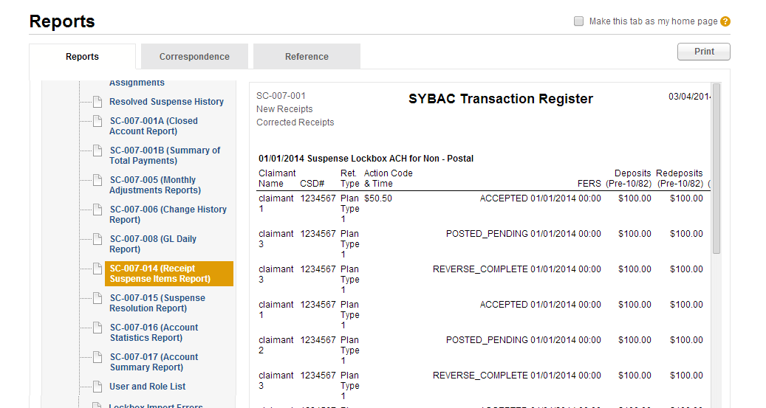

Please choose the date from 01/01/2014 – 03/05/2014 for this case:
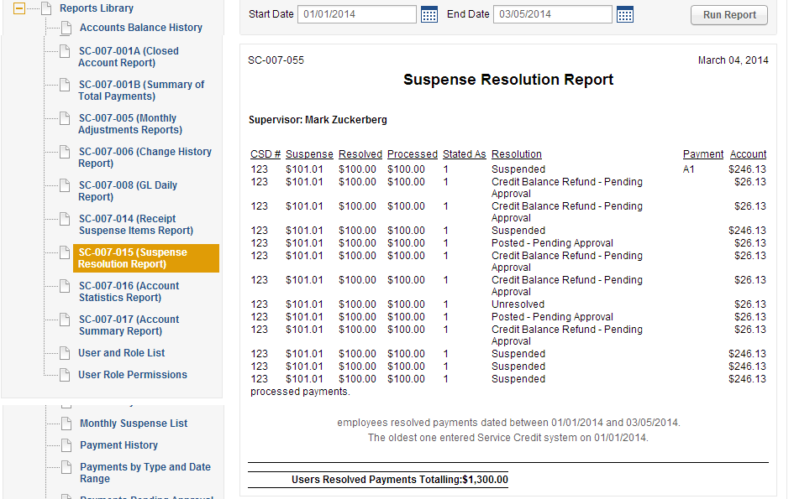

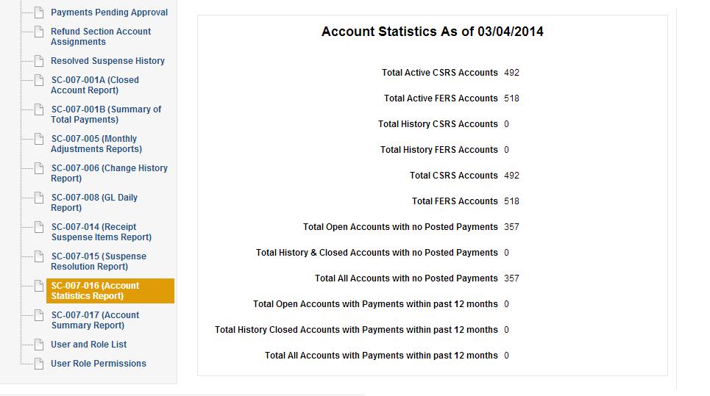

Use the csd 919259 for this case:
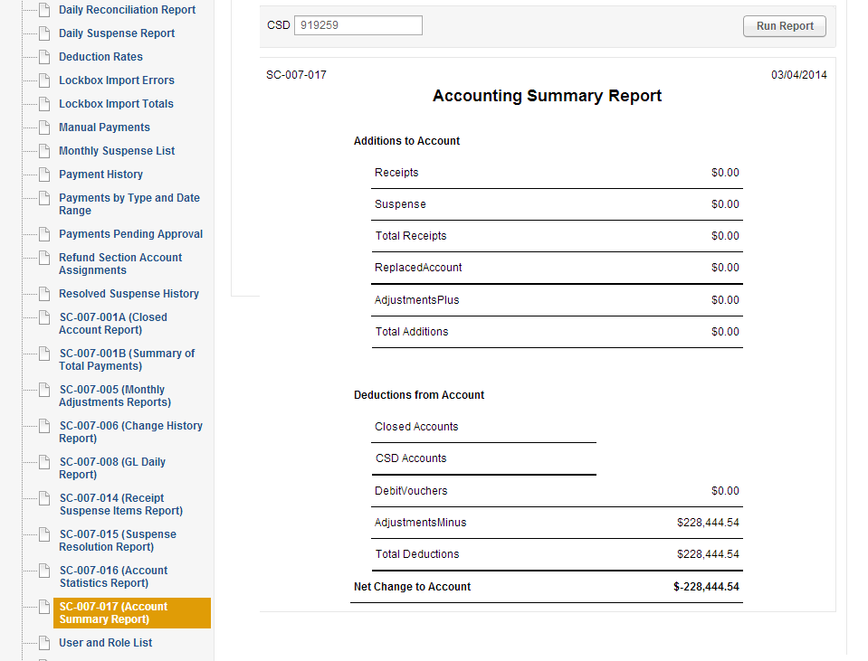

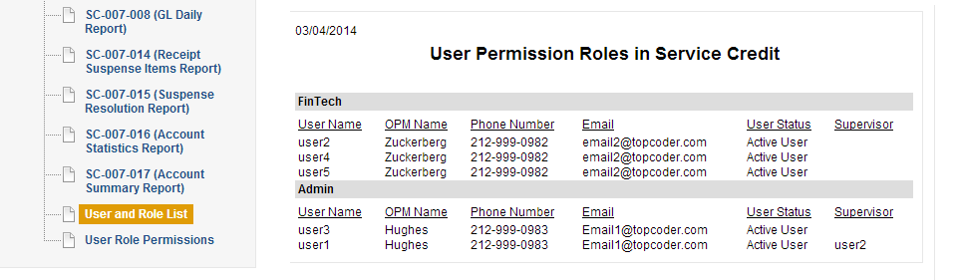

Please use csd 919259 for this case:
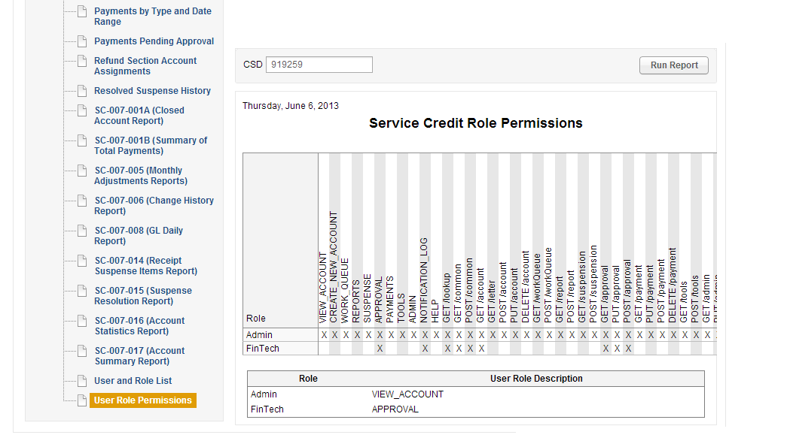

Reportings In other pages.

Click in the account details page
1). Click the View Account Tab
2). Click “search”
3). Click any account in the search result

Note, in this page, Print Summary is in the scope, print statement is not.

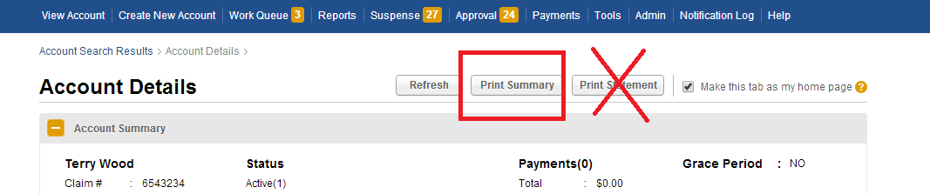

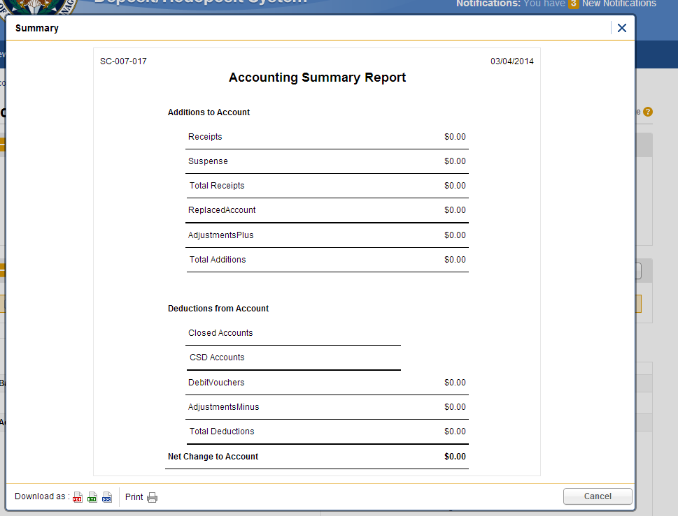

Go to the suspense page:
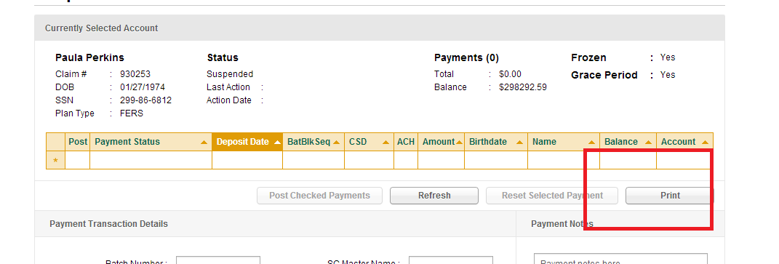

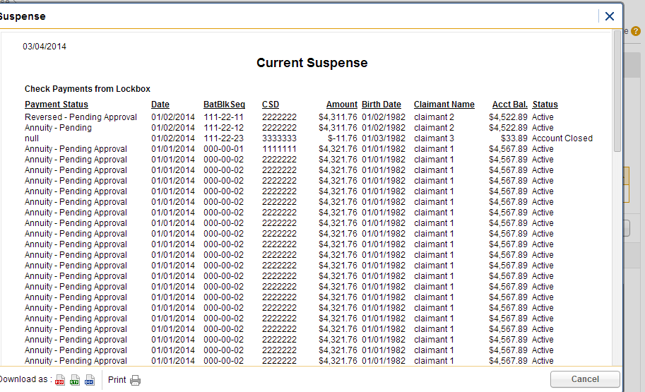

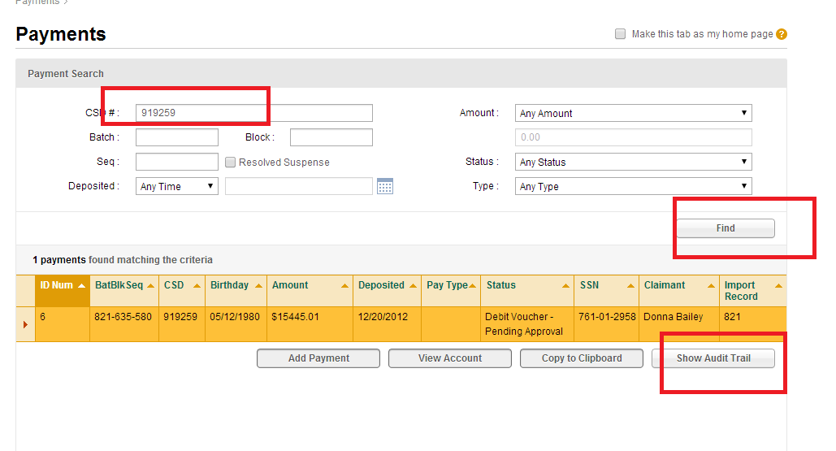

Go to Payments tab, search csd 919259, click “show Audit Trail”
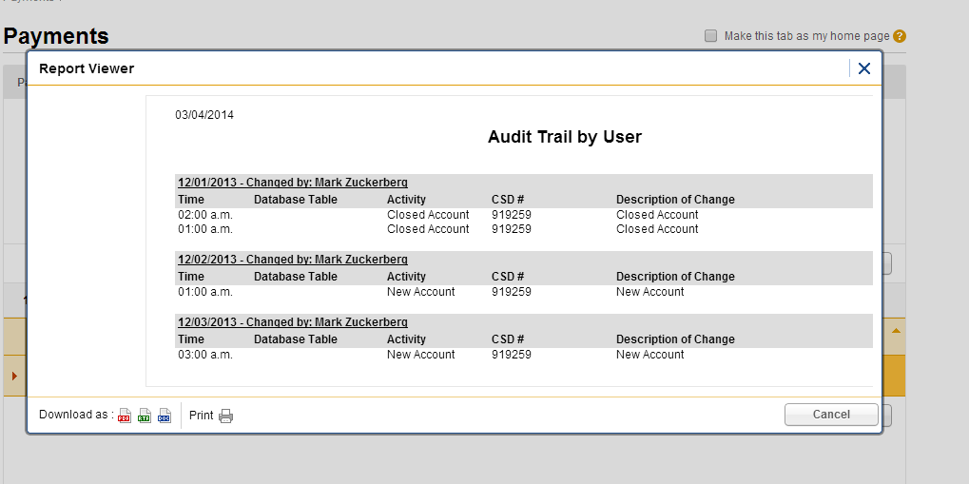

Resource Contact List

Name | Resource Email
TCSASSEMBLER

